AI-Assisted Artifact Identification & Sorting System

FIRST LEGO League Unearthed – Innovation Project
Team Name: (TBD)
Version: 1.0
Chosen Architecture: Robot + Software App (Option 3)

1. Problem Statement
Archaeologists discover thousands of artifacts during excavations.
Today, measuring, documenting, and categorizing artifacts is largely manual, which makes the process:
- Slow and time-consuming
- Inconsistent between teams
- Prone to human error
- Difficult to compare with historical data in real time
These limitations can lead to misidentification, which may significantly impact our understanding of ancient civilizations.

2. Proposed Solution (Innovation)
We propose an AI-assisted robotic and software system that helps archaeologists:
- Capture accurate measurements and images of artifacts
- Automatically organize and label findings
- Compare artifacts with historical data
- Estimate possible artifact type, age, and civilization
The system improves speed, accuracy, and consistency, while still allowing archaeologists to review and update results.

3. High-Level System Architecture

Final Selected Option:

Option 3 – Robot Integrated with App
The solution consists of two connected components:
- Artifact Scanning Robot
- AI-Powered Software Application (Web/App)
The robot collects physical data and sends it to the app.
The app analyzes the data, stores results, and assists with identification.

4. Functional Requirements

4.1 Robot Requirements
The robot must:
- Measure Artifacts
  - Length
  - Width
  - Height
- Capture Visual Data
  - Minimum of 5 images per artifact
  - Images from multiple angles
- Assign a Unique Artifact ID
  - Each artifact receives a unique number or QR code
- Send Data to the App Automatically
  - Via Bluetooth / Wi-Fi / USB (simulated for FLL)

Robot Sensors & Attachments (Conceptual)
- Camera (LEGO or external)
- Distance or ultrasonic sensor (for measurements)
- Optional: Light sensor or simulated LiDAR logic
- Gripper or platform to hold artifact steady
⚠️ For FLL feasibility, measurements can be approximated and explained as “scaled prototype behavior.”

4.2 Software App Requirements
The application must accept the following inputs from the robot:

Input Data
- Artifact images
- Measurements
- Location data
- Time of discovery
- Additional observed characteristics

App Capabilities
The app should:
- Store Artifact Records
  - Save all data linked to a unique artifact ID
- Analyze Artifacts Using AI
  - Compare against stored historical artifact data
  - Identify possible artifact type (e.g., bone, pot, tool)
  - Estimate approximate age range
  - Suggest possible civilization or culture
  - If the artifact is not classifiable, then mark the artifact as not classifiable.
- Contextual Comparison
  - Look for similar artifacts found within a 15-mile radius (simulated dataset)
- Human-in-the-Loop Editing
  - Allow archaeologists to update or correct AI results
- User Interface to view Stored artifacts and Classification Results
  - Should have a page where past artifacts are shown and can be searched for
    - Page sample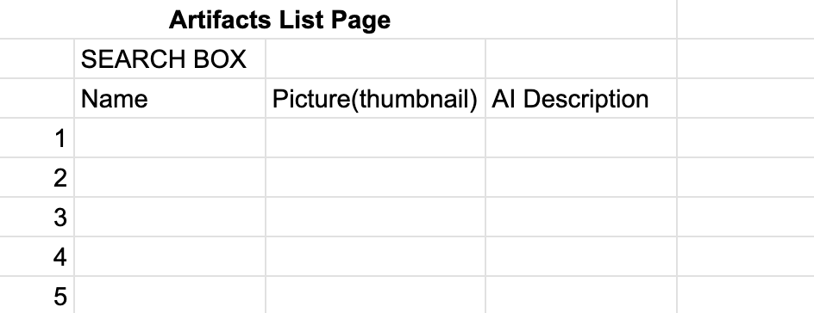
  - A second Artifact details page, which will show details about the artifact, pictures, AI Summary, AI classification details, Additional details etc. The page should also have an edit button for archaeologists to edit the details.
    - 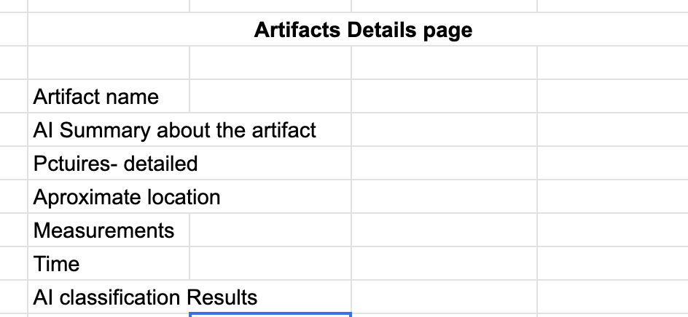
    - Should approximate the location in viewing pages to avoid location privacy issues.
  - Artifact input page - this page allows users to upload artifact images and measurements and have the App to perform the classification.
  - The app has different kind of users
    - Public audience - can view and search artifacts. No login required
    - Archeologists - can view and edit artifacts, requires a login.
  - Only authorized Archeologist users are allowed to make changes to categorization of artifacts.

5. Data Contract (Robot → App)

Input Format (JSON)
{
"artifact_id": "ART-000123",
"images": [
"image_url_1",
"image_url_2",
"image_url_3",
"image_url_4",
"image_url_5"
],
"location": {
"latitude": 37.4219,
"longitude": -122.0840
},
"timestamp": "2026-02-14T10:32:00Z",
"measurements": {
"length_cm": 12.4,
"width_cm": 6.1,
"height_cm": 4.8
},
"additional_info": {
"hollow": true,
"material_guess": "clay",
"shape": "cylindrical"
}
}

6. AI & Classification Logic

The app will use AI to:
- Classify artifact type
- Match with historical datasets
- Generate confidence scores

Potential AI interfaces to consider are ChatGPT and Gemini. The APP will interface with either chat gpt or gemini(possibly both) via APIs( for the initial prototype, later it can be enhanced to use custom AI classification models/logic)

AI Approach (FLL-Appropriate Explanation)
- Image recognition (pre-trained model concept)
- Rule-based + ML classification
- Large Language Model (LLM) for summarization and explanation
Example:
“This artifact is likely a clay pot fragment from the Bronze Age, based on shape, size, and similar artifacts found nearby.”

7. Non-Functional Requirements
Category | Requirement
Performance | Results generated in under 5 seconds
Accuracy | Provide confidence score for each prediction
Usability | Simple UI suitable for field use
Scalability | Supports thousands of artifact records
Reliability | Data saved even if network is unavailable

8. Constraints & Risks

Constraints
- Prototype scale (FLL-friendly)
- Limited hardware sensors
- Simulated datasets instead of real archaeological databases

Risks
- Cost of real-world implementation
- Complexity of AI training
- Weight and size of robot

9. Why This Is Innovative (Judges Section)
- Combines robotics + AI + archaeology
- Reduces human error in artifact documentation
- Helps preserve history more accurately
- Scalable for real archaeological expeditions
- Supports scientists without replacing them

